**TASK IAM**

**1-Create one IAM user and assign ec2,s3 full access role**

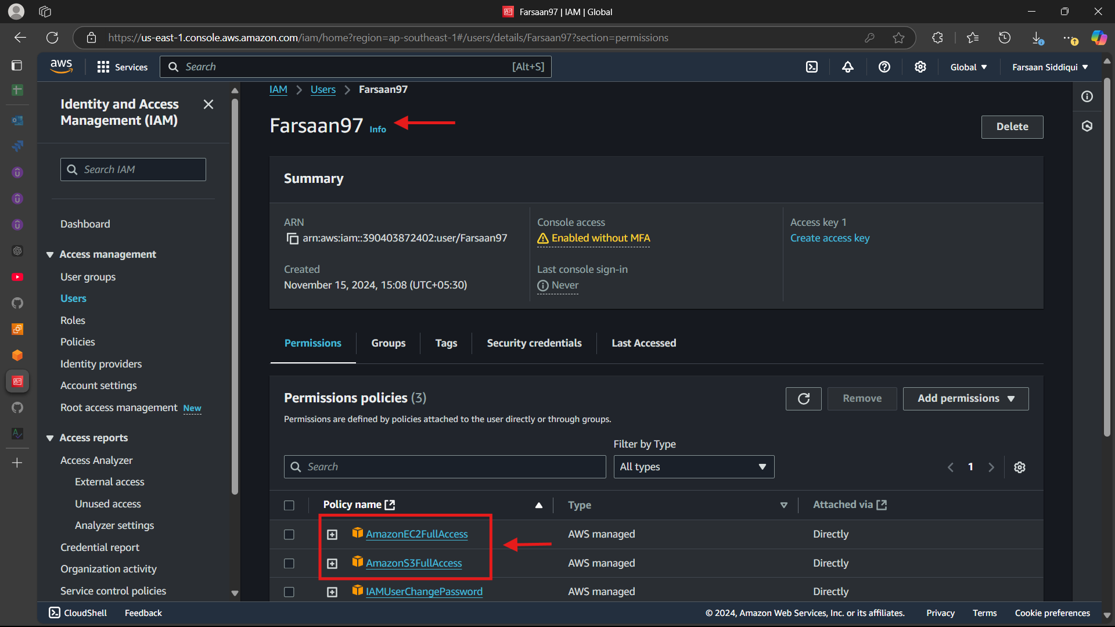

*Checking by loggin in with <Farsaan97>

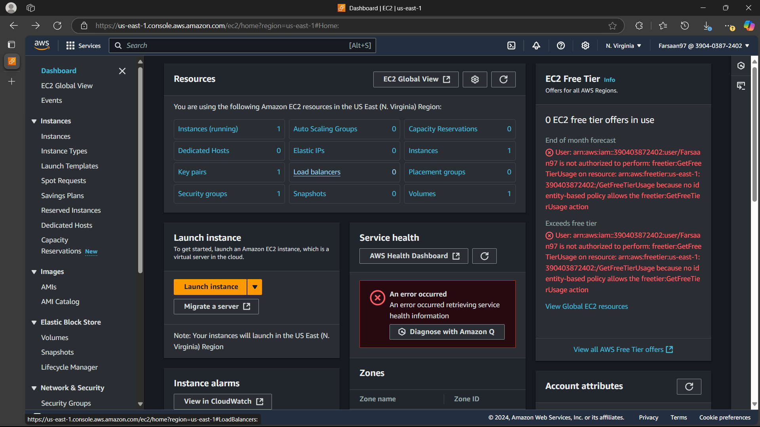

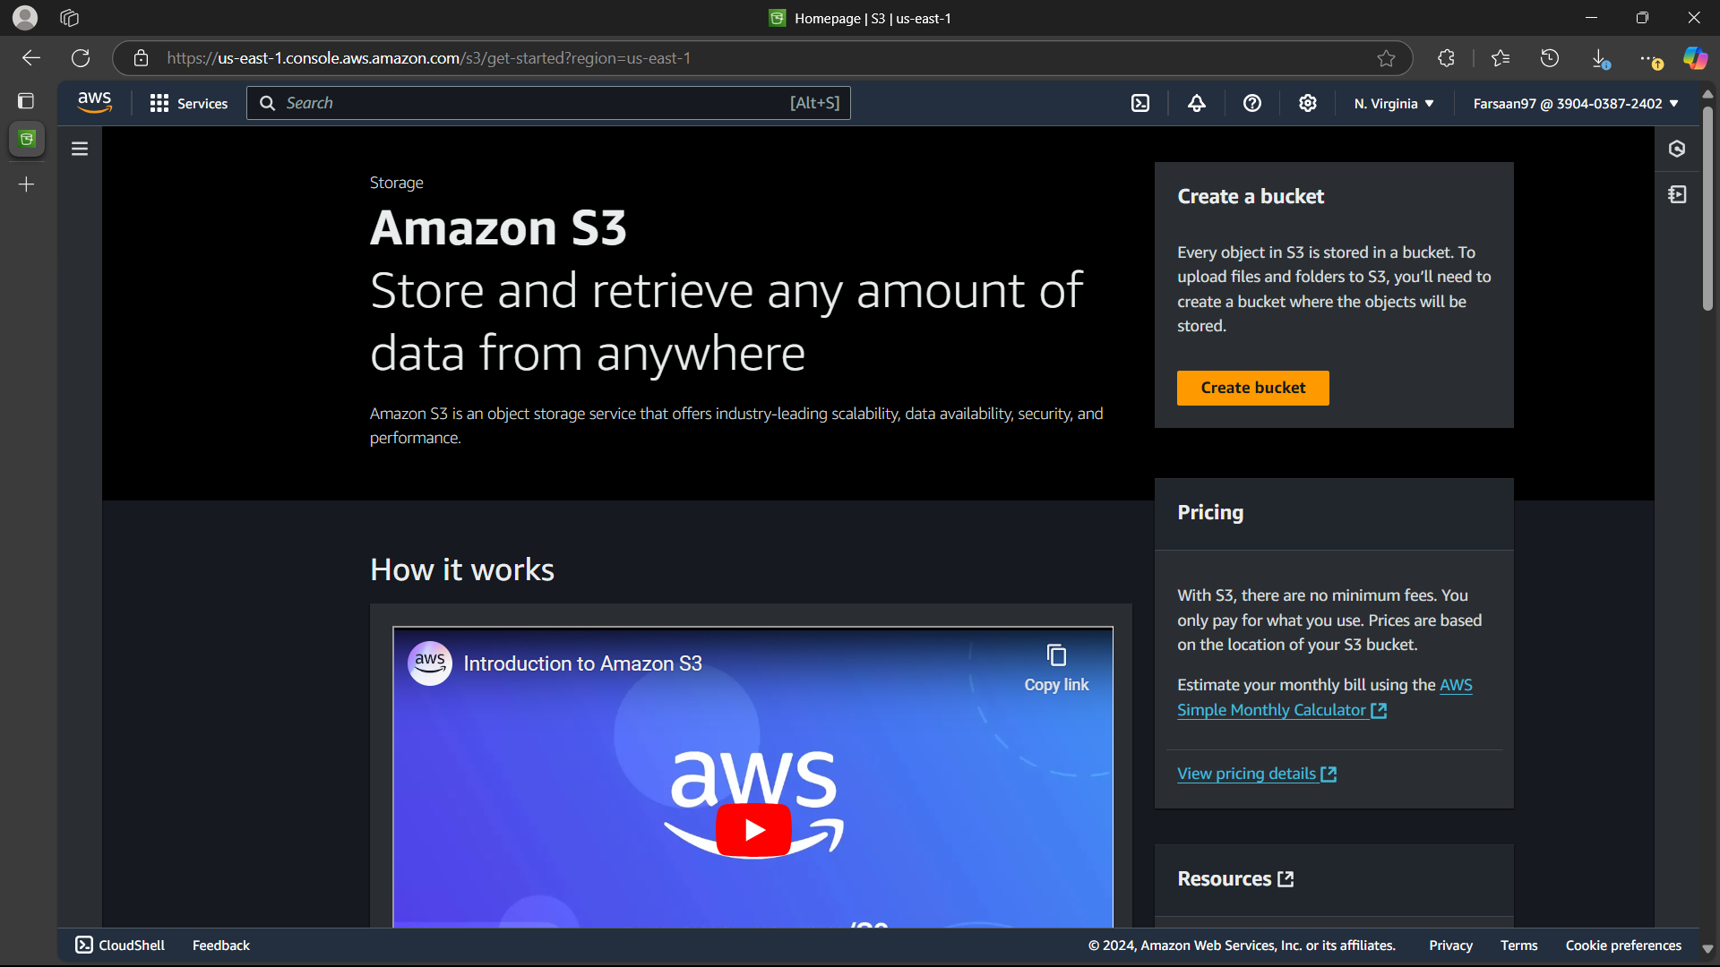

**2.Create one Group in IAM and Assign Read access for ec2**

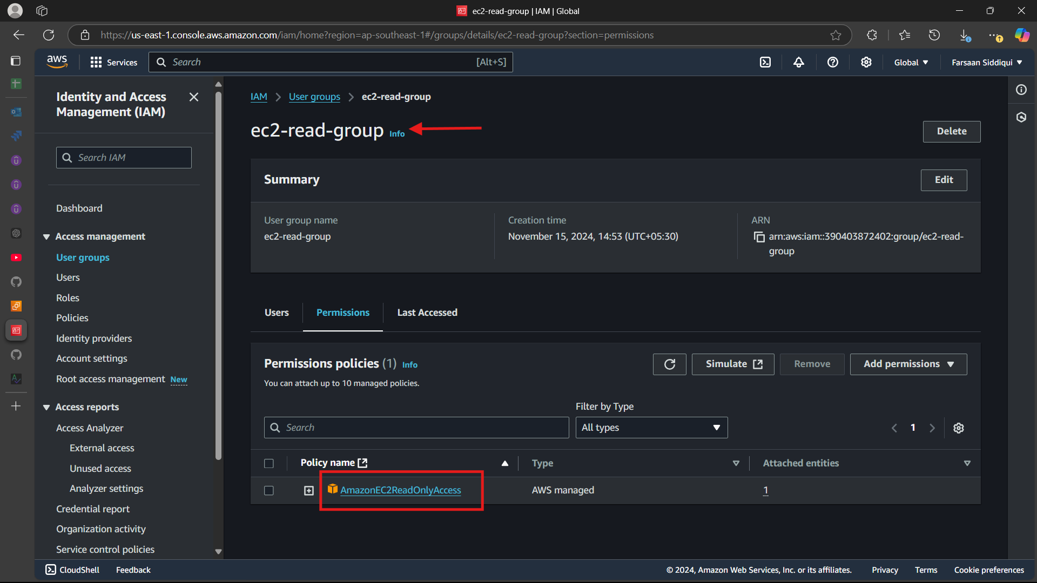

**3.Create a new user with name Devops and add to the group created in task2**

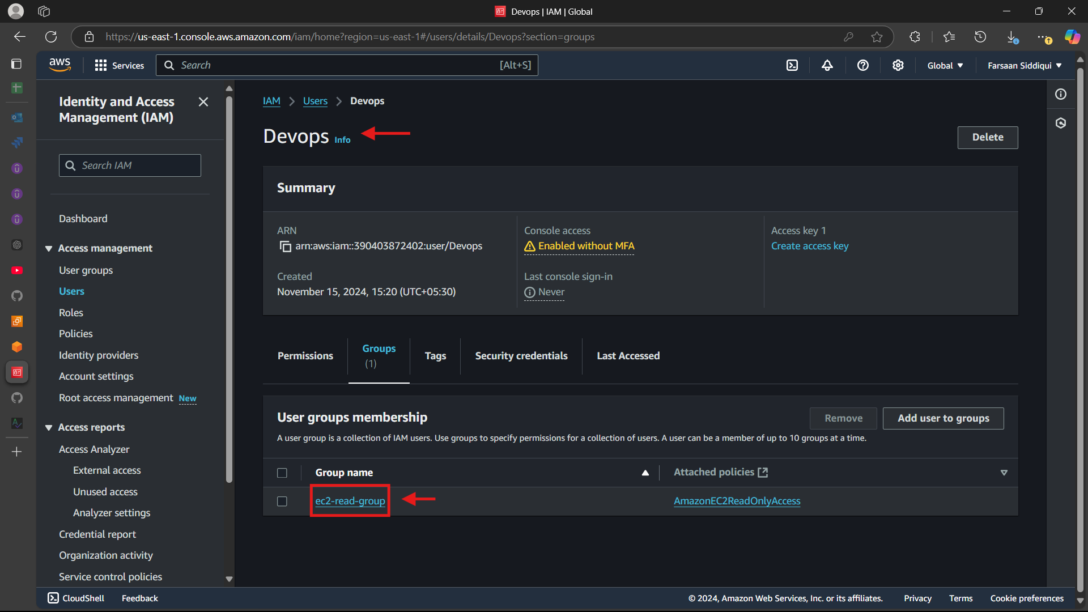

*Checking by logging in as Devops if we have only read access or we can connect to ec2

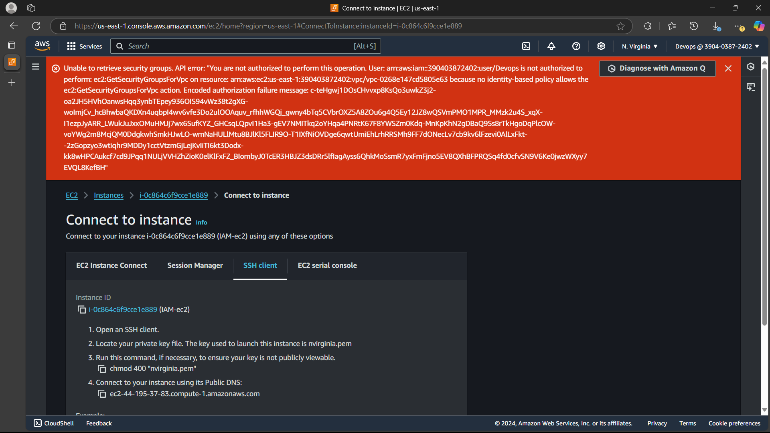

**4.Write a bash script to create a IAM user with VPC full access**

**#!/bin/bash**

**USER_NAME**=**"vpc_iam_ujser"**

**POLICY_NAME**=**"VPCFullAccessPolicy"**

**# Create IAM user**

aws iam create-user **--user-name** **$USER_NAME**

**# Attach policy to the user**

aws iam attach-user-policy **--user-name** **$USER_NAME** **--policy-arn** arn:aws:iam::aws:policy/AmazonVPCFullAccess

**# Create login profile for console access**

aws iam create-login-profile **--user-name** **$USER_NAME** **--password** **"Devops@123"** **--password-reset-required**

**echo "IAM user $USER_NAME created with VPC full access and console access."**

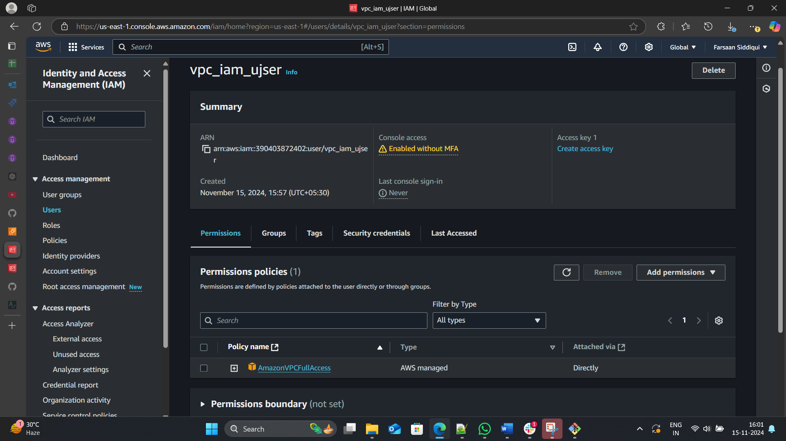

**5.Create a IAM policy to access ec2 for a specific user in specific regions only**

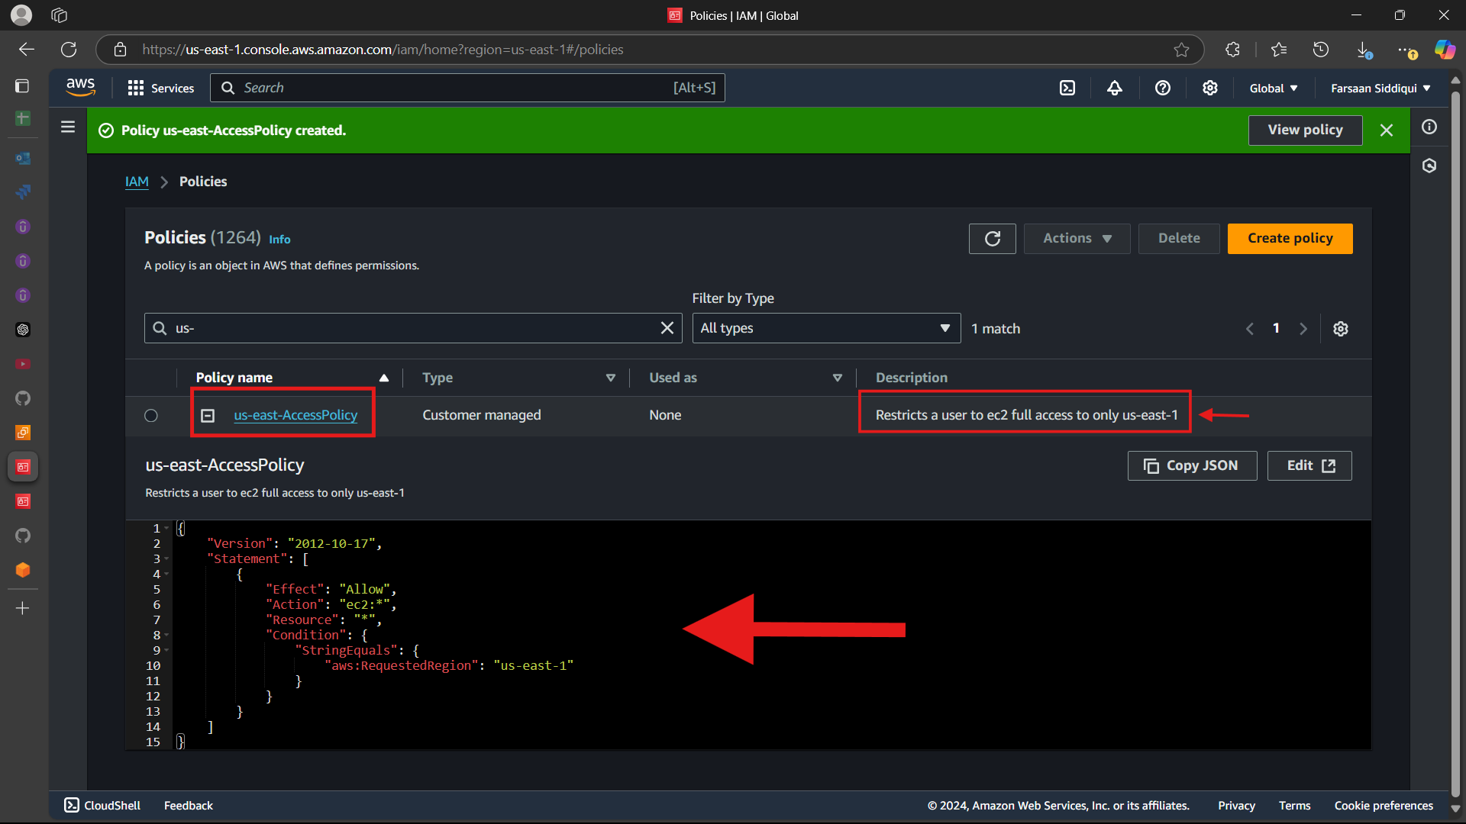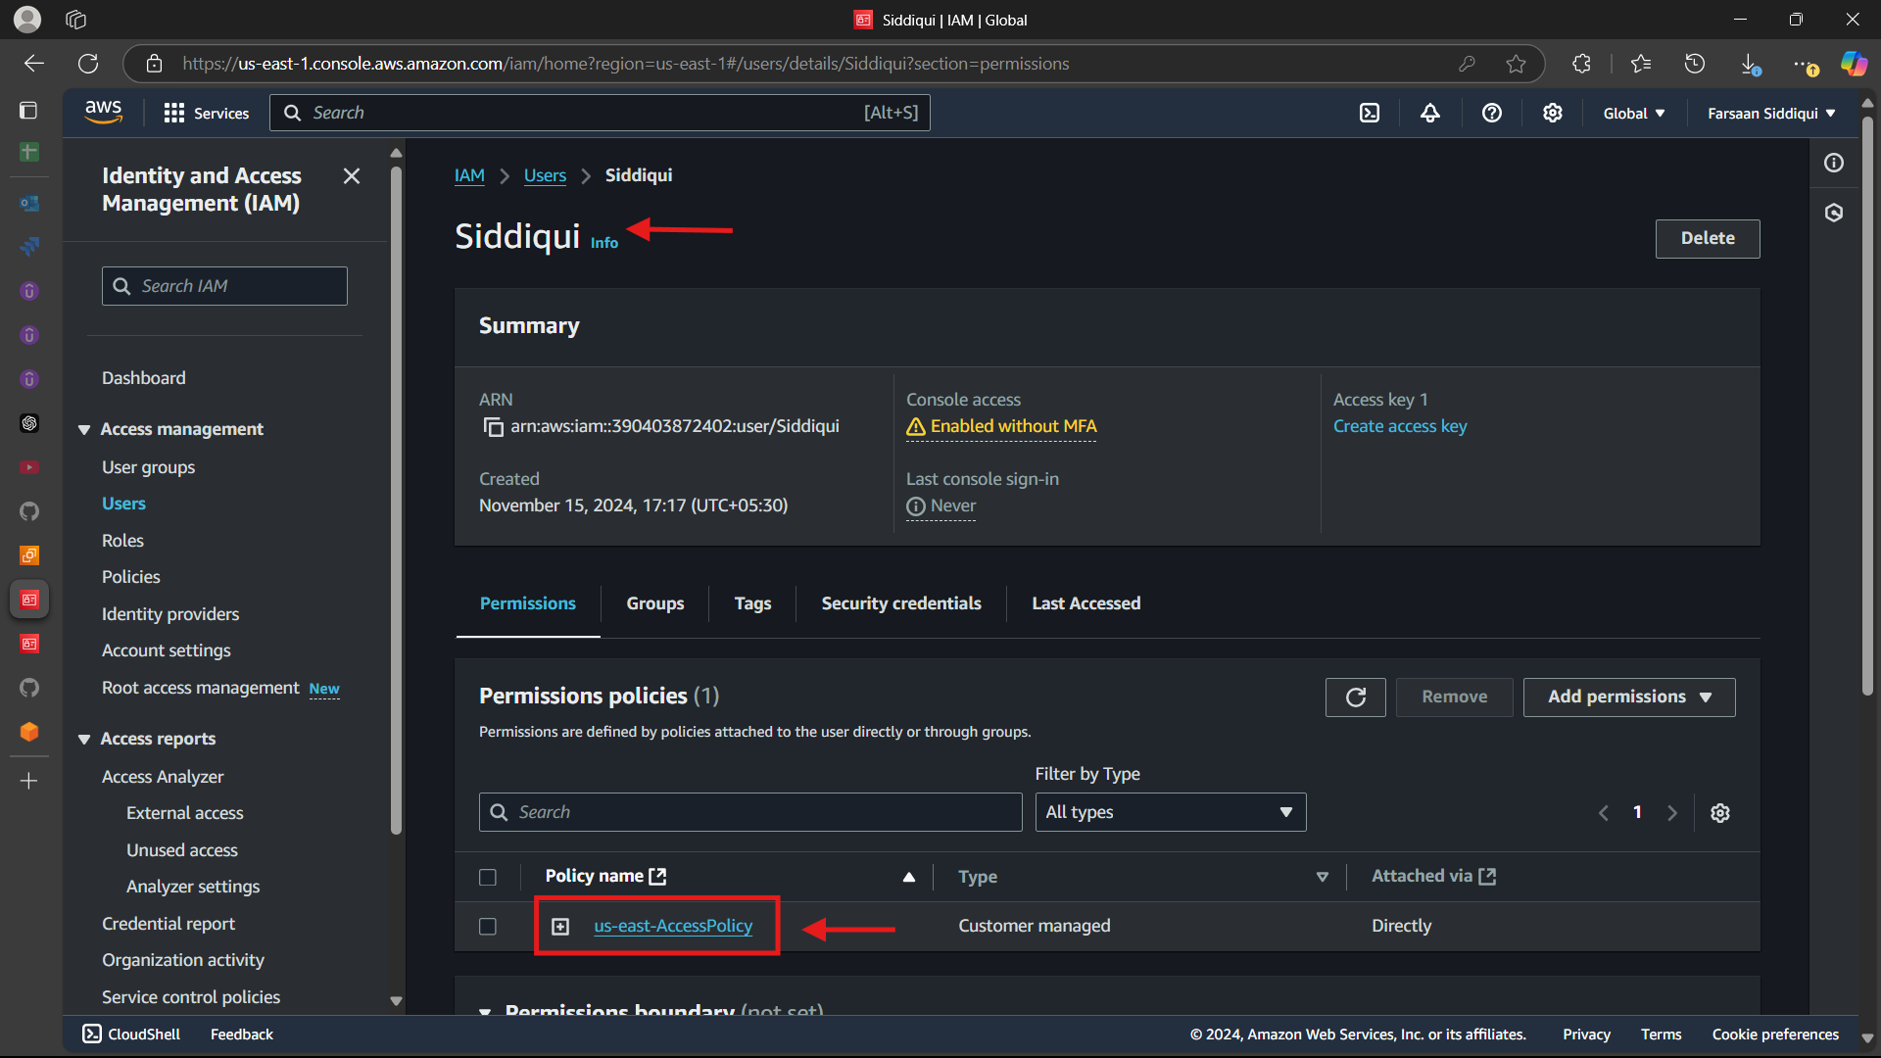

*Logging in as Siddiqui as trying to change region and access ec2 service

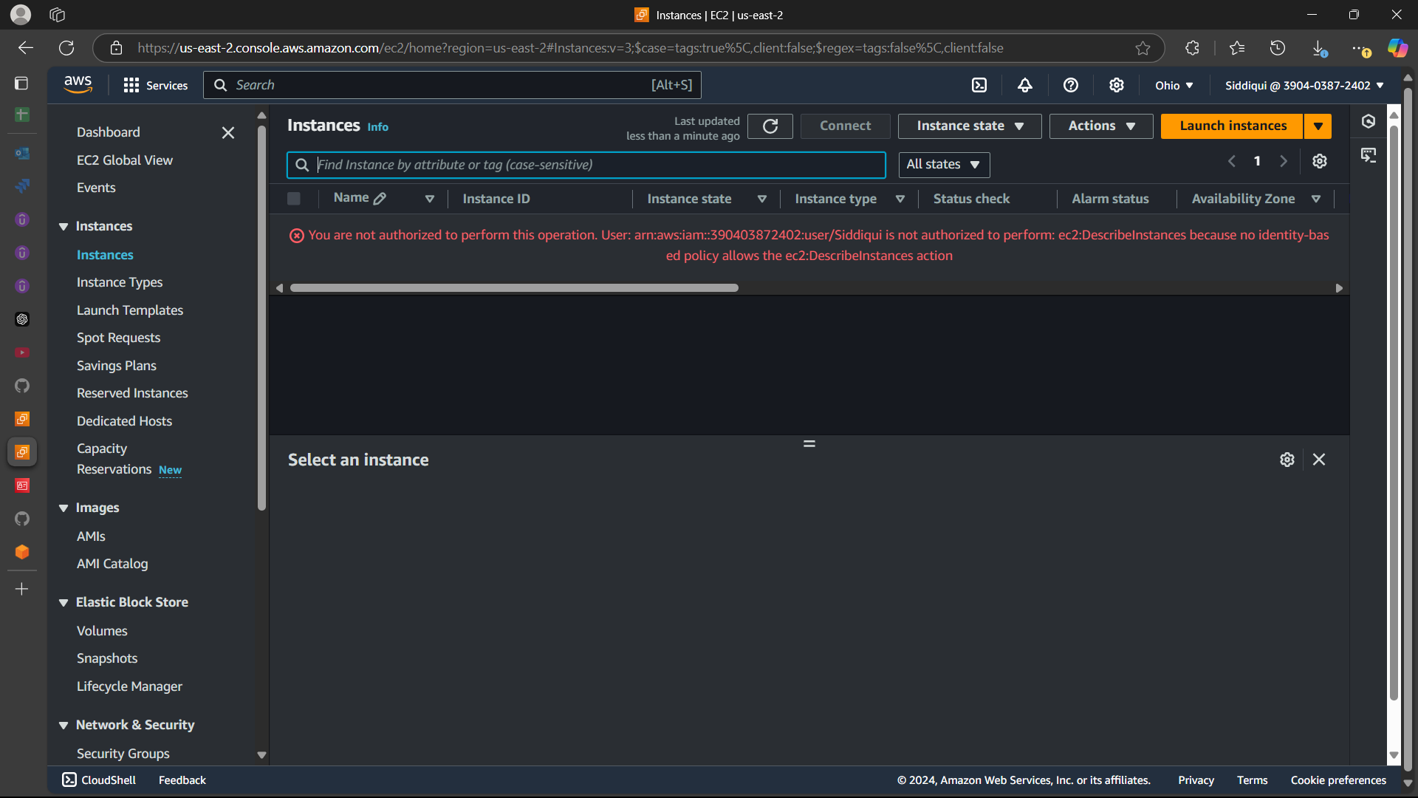

**~~<We have two accounts Account A and Account B, Account A user should access s3 bucket in Account B. >~~**